***ROLL#BSEF17A531***

***NAME:HURAIRA IRFAN***

***LAB#1 (OS)***

*ANSWERS AND SCREENSHOTS:*

*1)*

*By using whoami we can see the current user name in the system.*

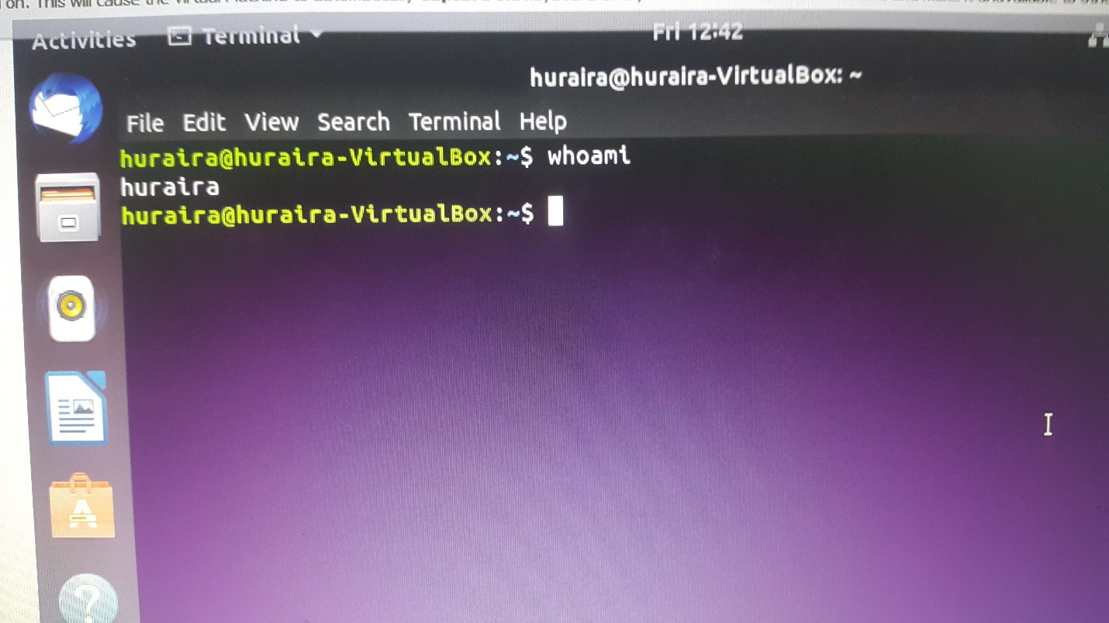

*2,3)*

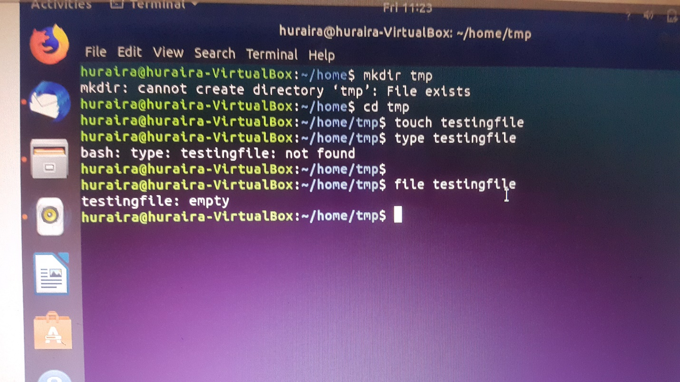

*4)we know rm is used to delete a file while rmdir is used to delete empty directory.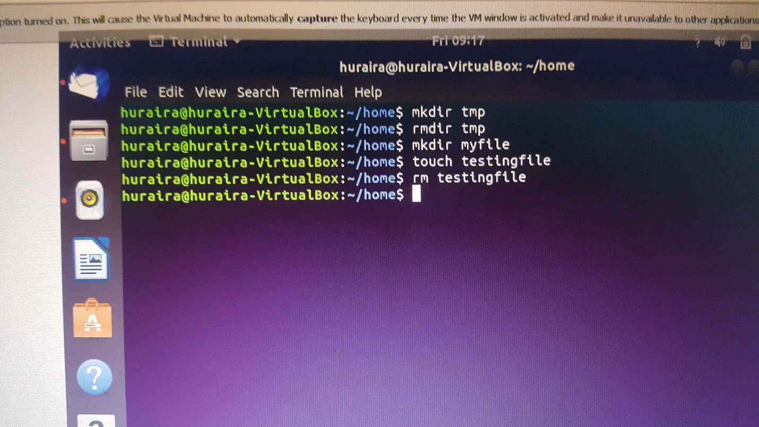*

5)cd will take to you to last home directory.

*6)*

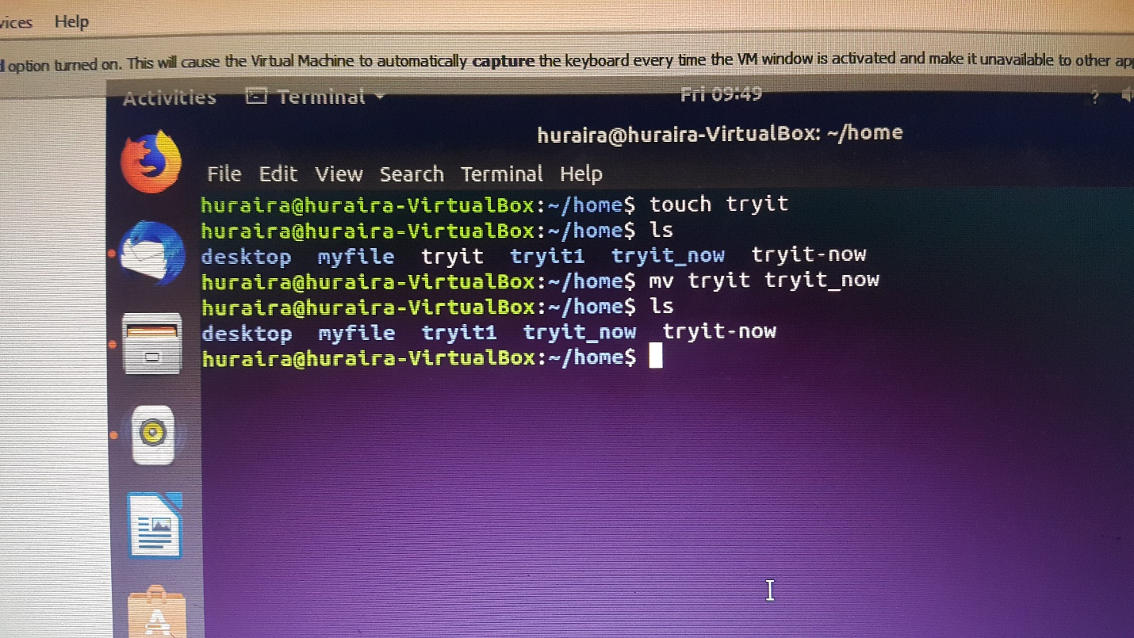

*7)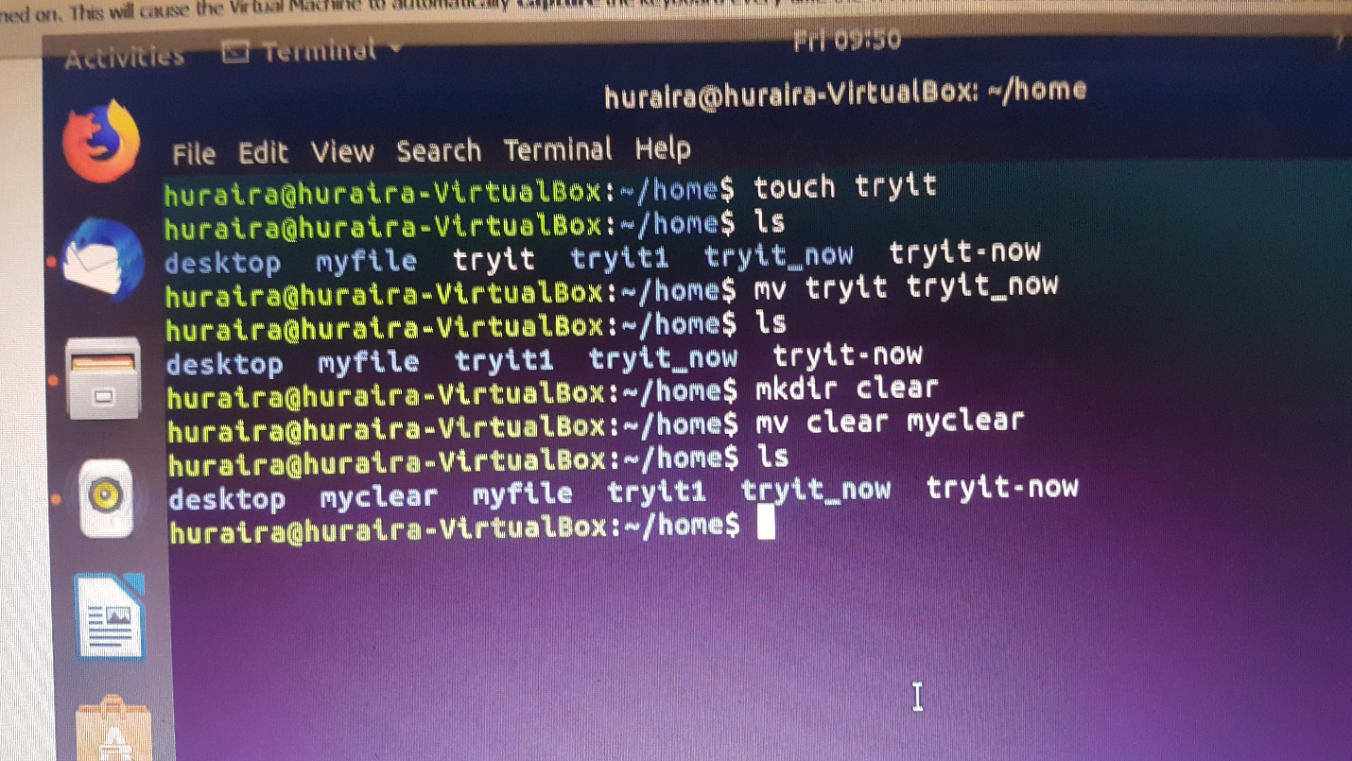*

*8 a)it will list all the files in directory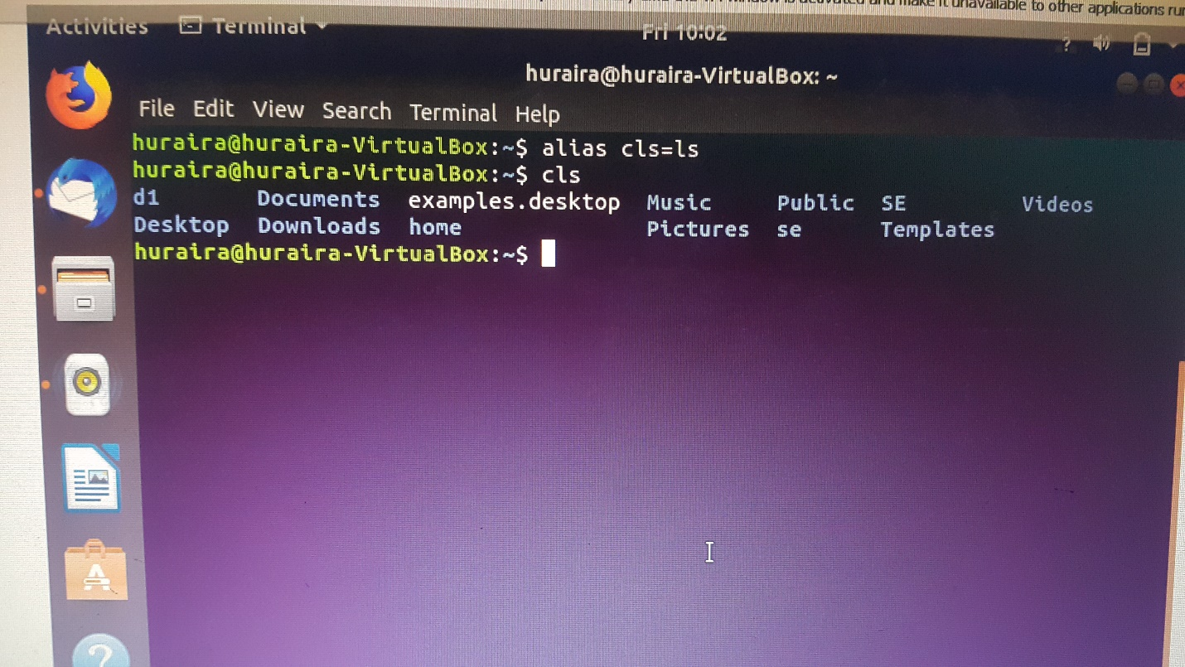*

*8 b)*

*it will print output that d1 directory is already exists in the home directory.*

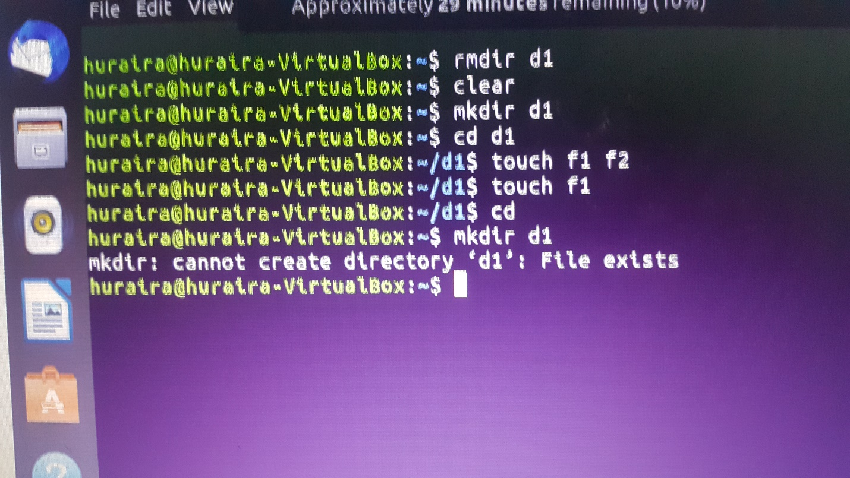

*Part 2)*

*1)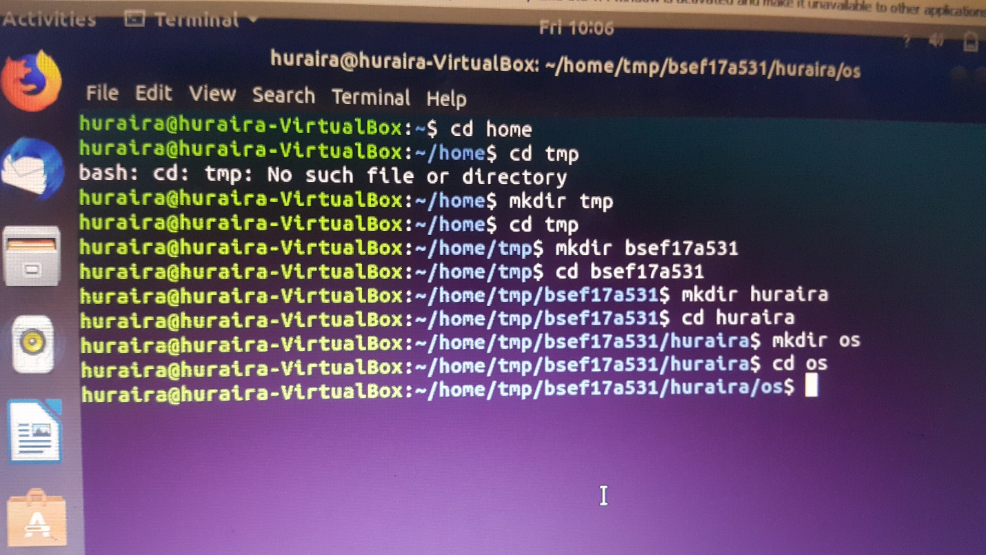*

*2)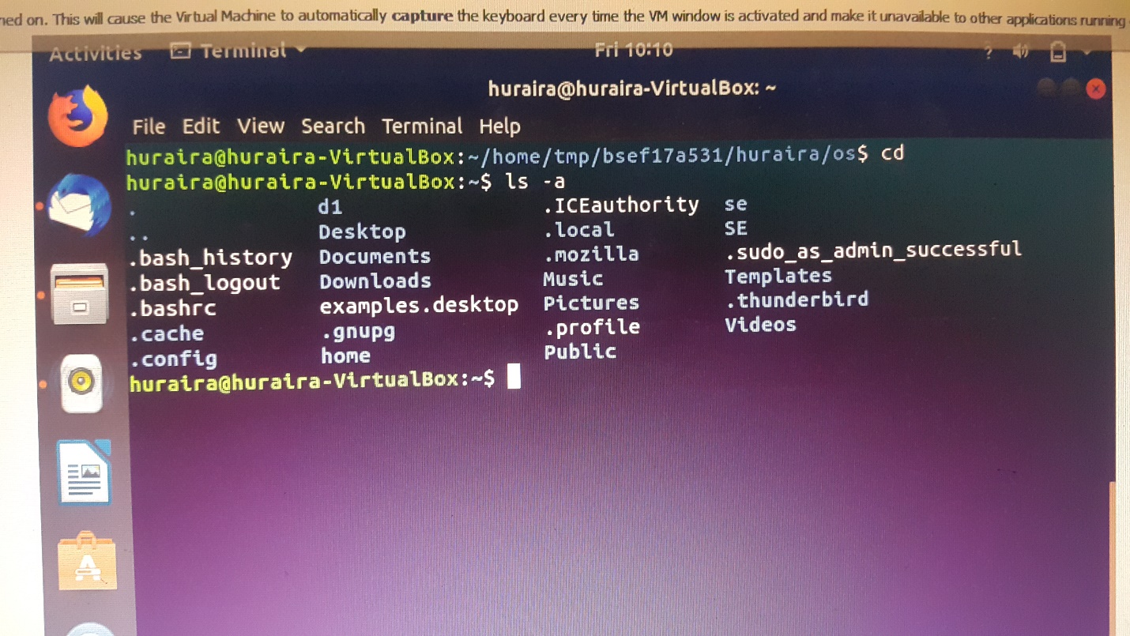*

*3) First method.1- rmdir /tmp/Bsef17a531/huraira/OS/ /tmp/bsef17a531/Huraira/ /tmp/Bsef17a531/*

*2- rm –r /tmp/Bsef17a531*

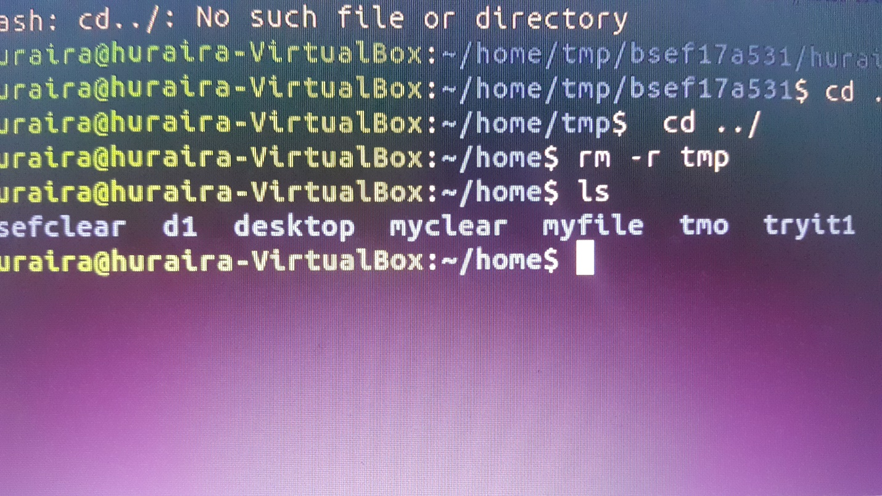

*4)*

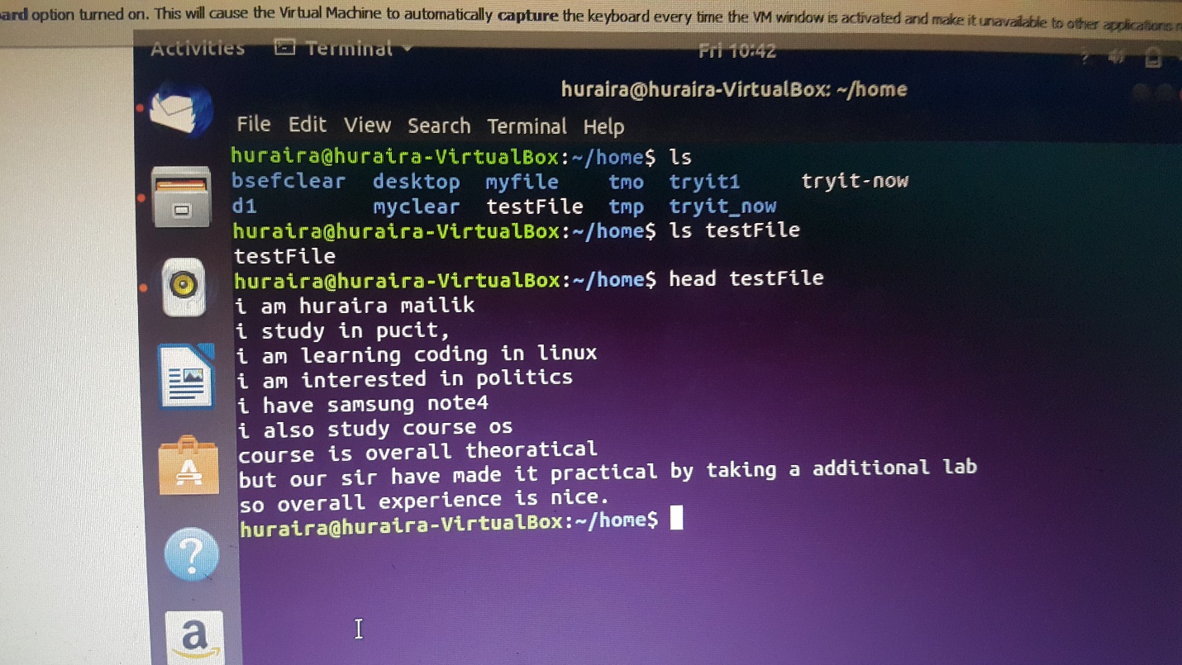

*5,6)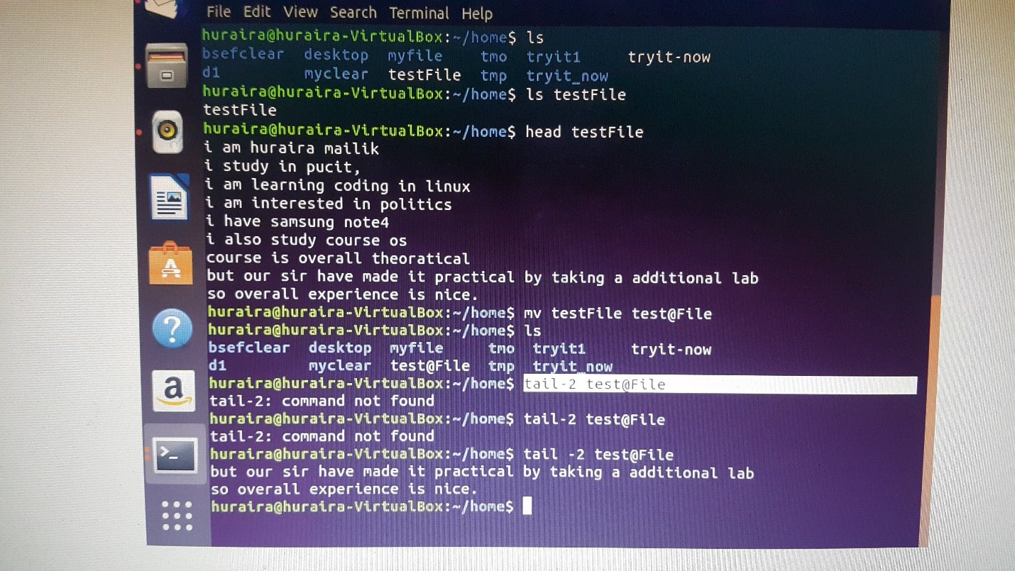*

*7)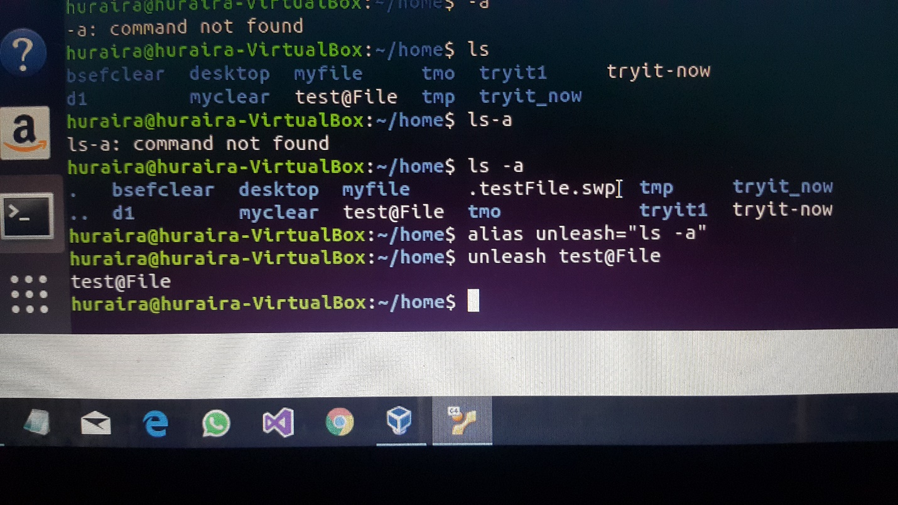*

*8)*

*We can use man command to see details of command before command it will print all info about it.*

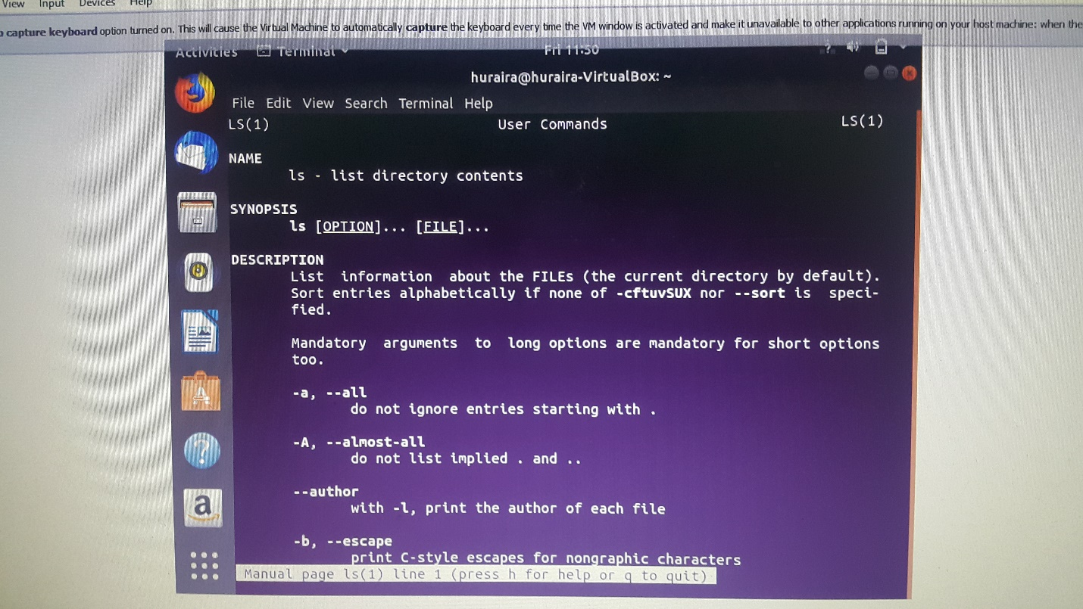

*9) we can write type before type to see whether it is internal or not.*

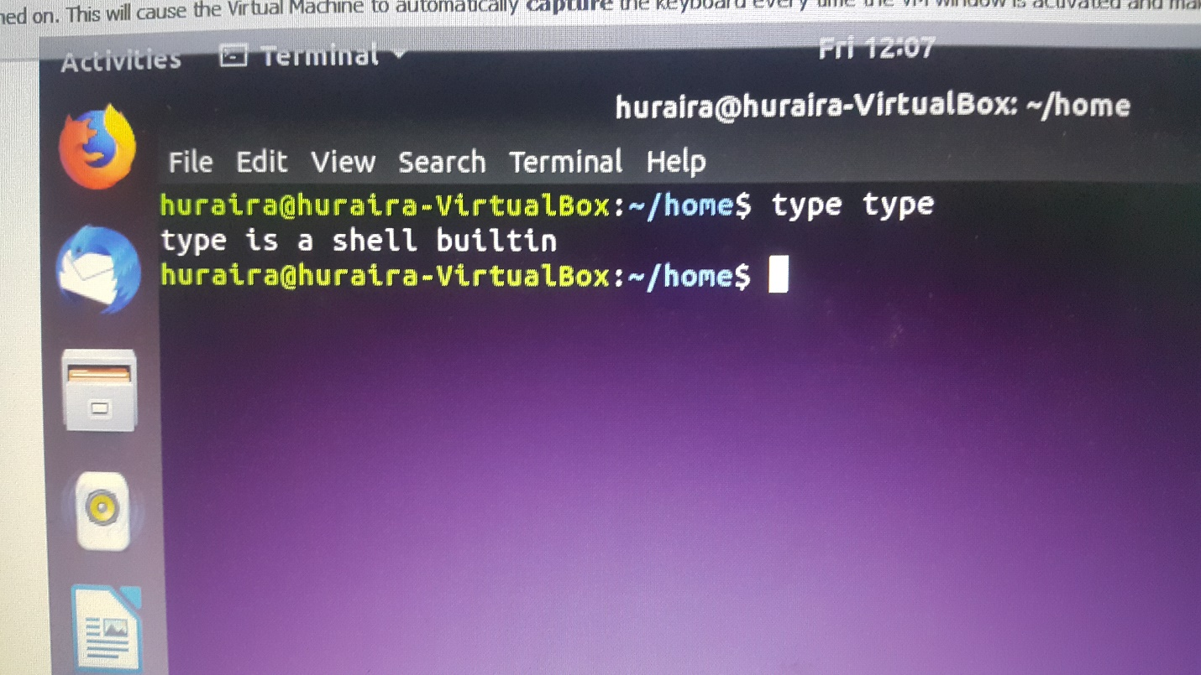

*10)*

*we can use a command rm -r before name for removing directory.*

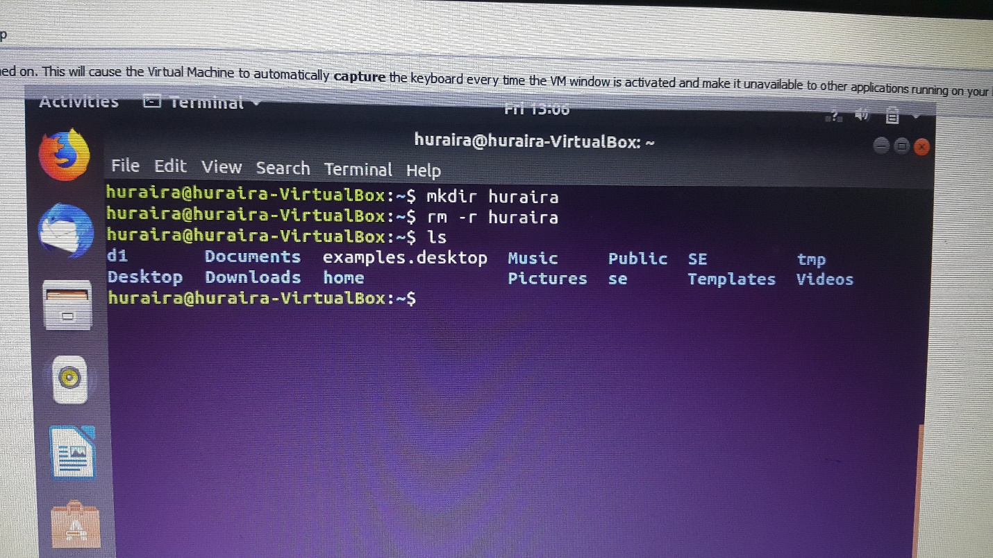

*Part(3) Absolute and Relative Path*

*1)*

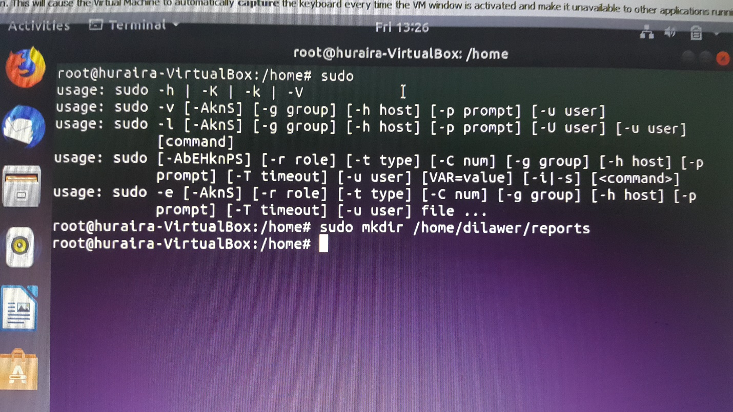

*2)*

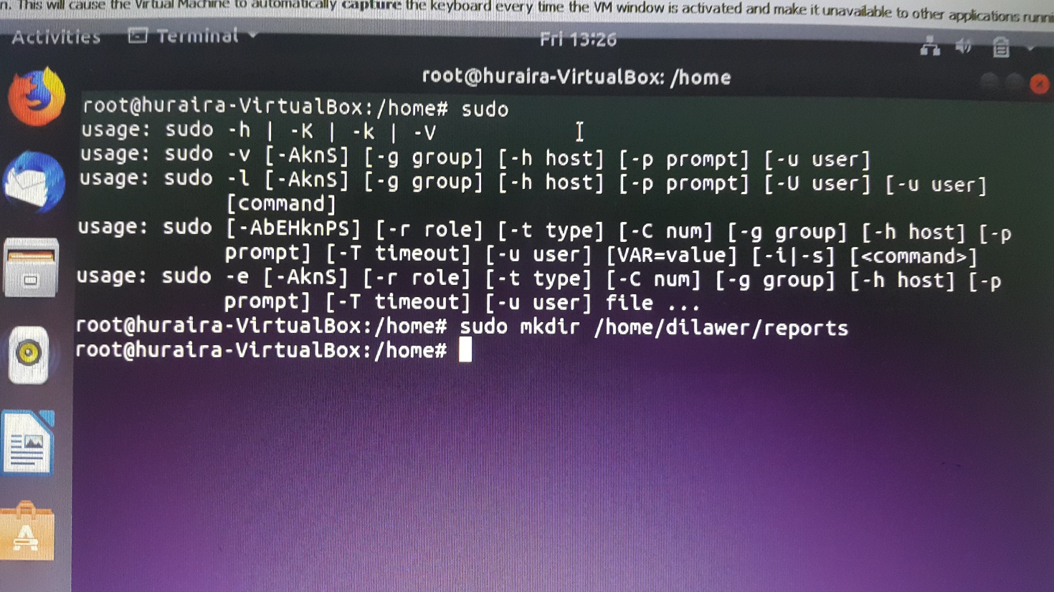

*3)*

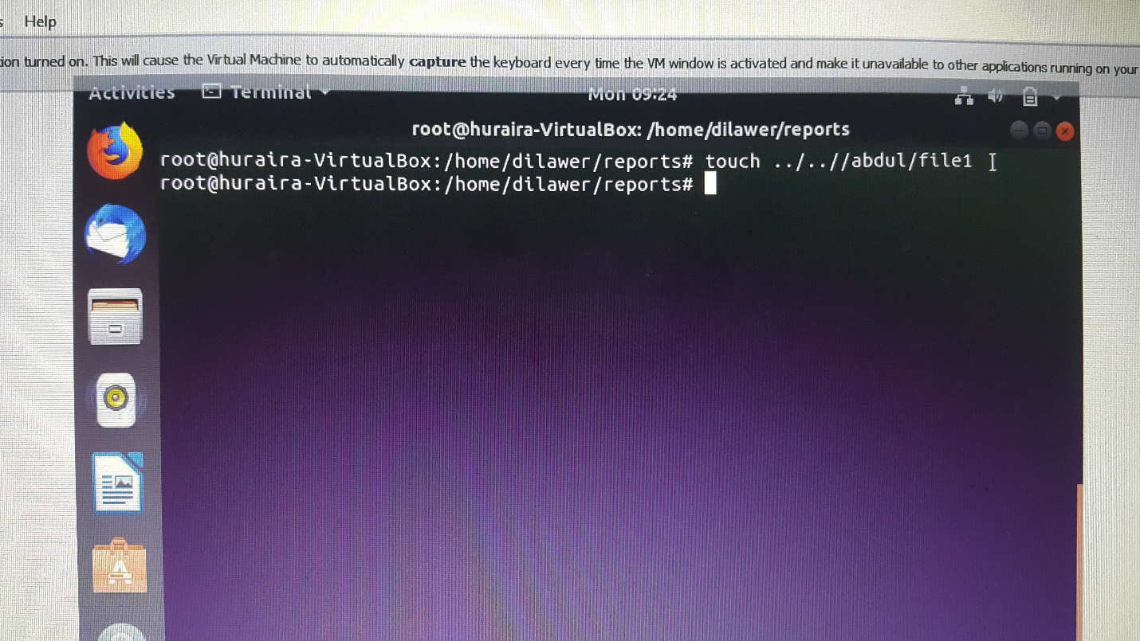

*4)*

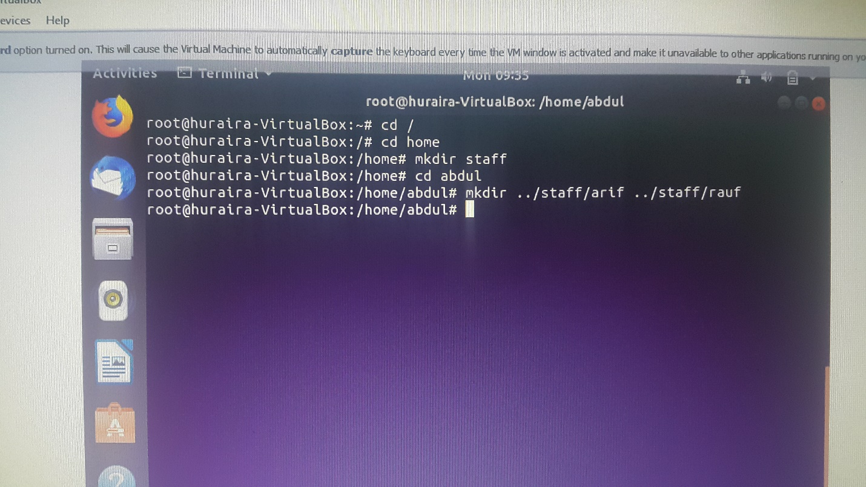

*5)*

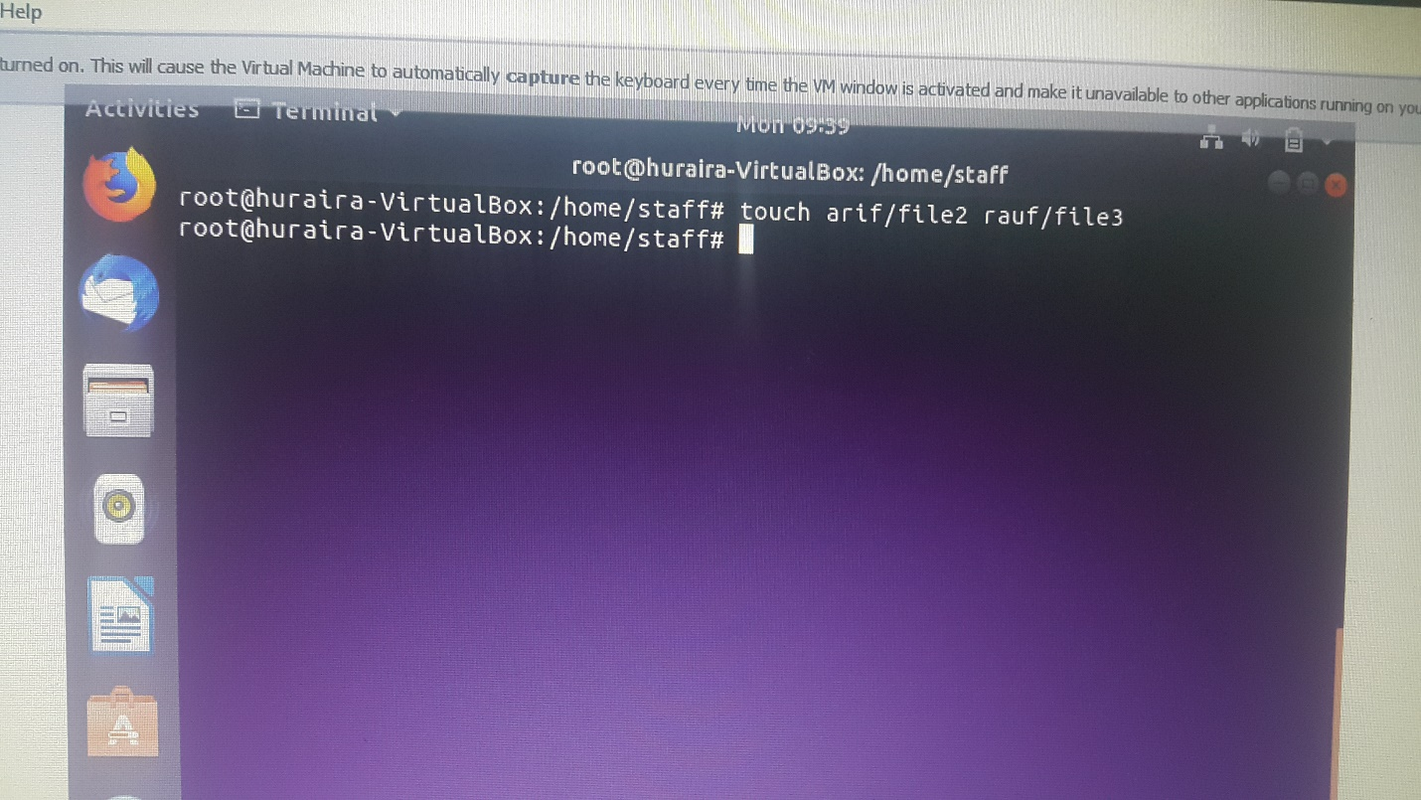

*6)*

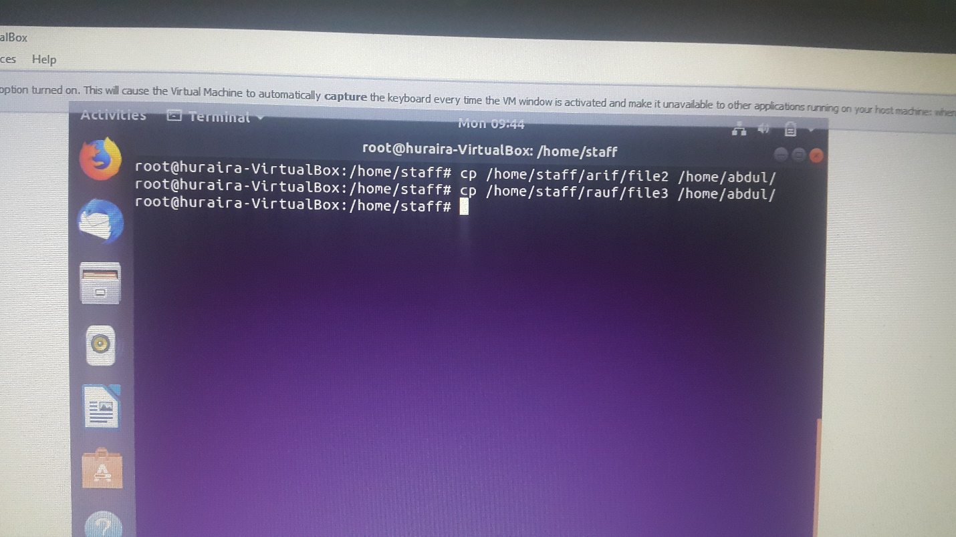

*7)*

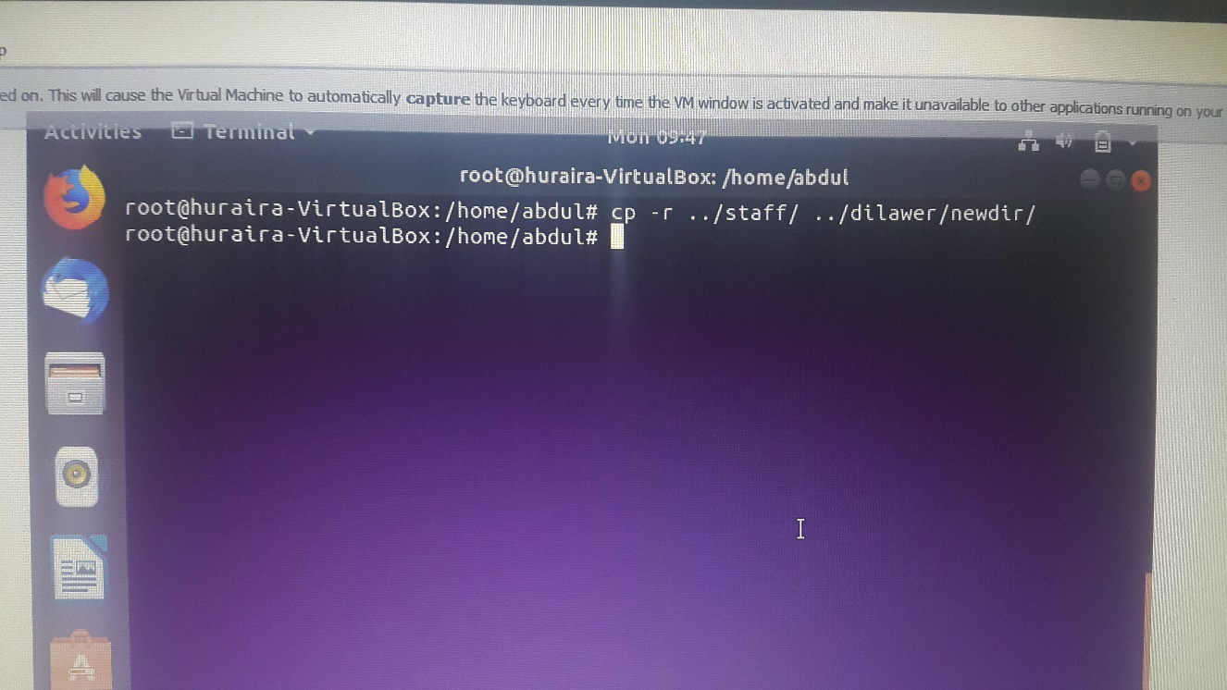

*8)*

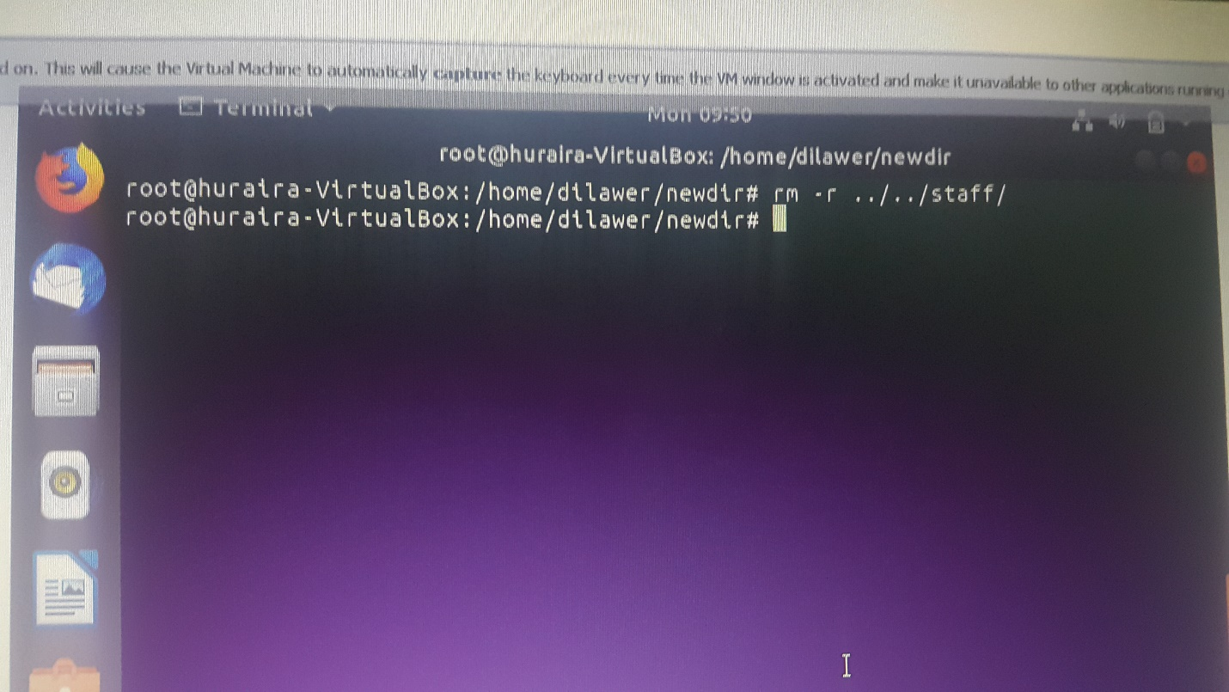

*9)*

